Project Title: ………

Frontend Design & Development (minimum 5 screenshots)

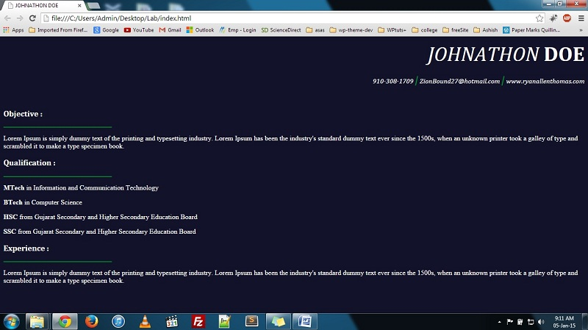

fig. 2.1Home Page

Note:
No plagiarism will be entertained. Such work will be rejected. Students are suggested to perform lab sessions on their own.

Practical are expected to be submitted within given deadline by faculty.

You need to follow this format with all its settings.
- Header [Lab title and Department name]
- Footer [Author name [enr. no.] and page number]
- Fonts and Font sizes

